**WERC 2025 Final Technical Report**

**Team Name:** *Renewable Energy Solution for Water & Environmental Restoration*  
**Institution:** New Mexico State University

**Team Members:**

* Naiqui Armendariz (AE/ME)
* Roberto Moreno (ME)
* Sohan Dissanayake (AE/ME)
* TJ Bell (Engineering Physics)
* Wyatt Ziehe (AE/ME)

**Advisor:** Luke Nogales, MET Coordinator, NMSU

**Email Contact:** narmen14@nmsu.edu | Phone: (575) 637-0077

**I. Executive Summary**

Wildfires dramatically degrade soil and water systems, often requiring decades for natural recovery. Our system accelerates the recovery process to 3–5 years using a wind-powered filtration system built from natural materials and monitored in real time via low-cost electronics. The project emphasizes sustainable materials, off-grid operation, and affordability for use in vulnerable communities.

**II. Problem Definition**

Wildfires introduce ash, debris, herbicides, and heavy metals into water and soil systems. Traditional remediation is costly, slow, and requires electricity. Our task was to engineer a low-cost, off-grid system to filter runoff and accelerate soil regeneration while monitoring the effectiveness of the process.

**III. Engineering Requirements & Metrics**

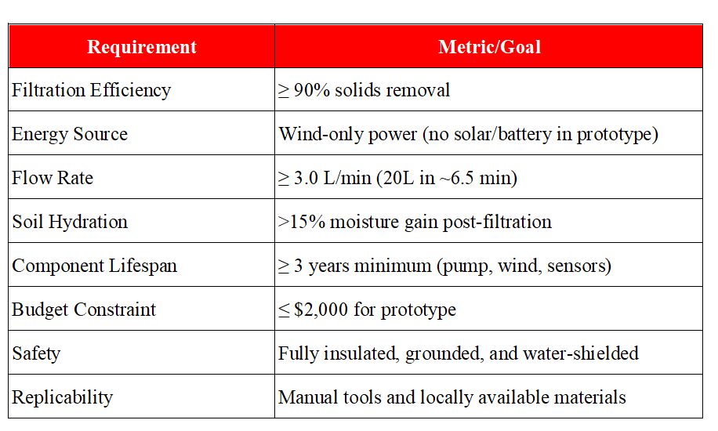

**IV. System Overview**

**A. Water Filtration System**

Filtration occurs in a column using gravity-fed water, driven by a wind-powered pump through layers of:

* Gravel and sand – sediment removal
* Lava rock – mineral filtration
* Coconut activated charcoal – chemical adsorption
* Cotton – fine particle capture

**B. Wind-Powered Delivery**

A vertical-axis wind turbine (~2.3 m tall) powers a Seaflo 42 Series diaphragm pump, which pushes 20L of water in ~6.5 minutes through the filter and soil box.

**C. Monitoring System**

Sensors connected to an ESP8266 microcontroller track:

* Soil moisture and temperature
* pH and conductivity (Separated testing module)
* Data logged daily and correlated with filter performance.

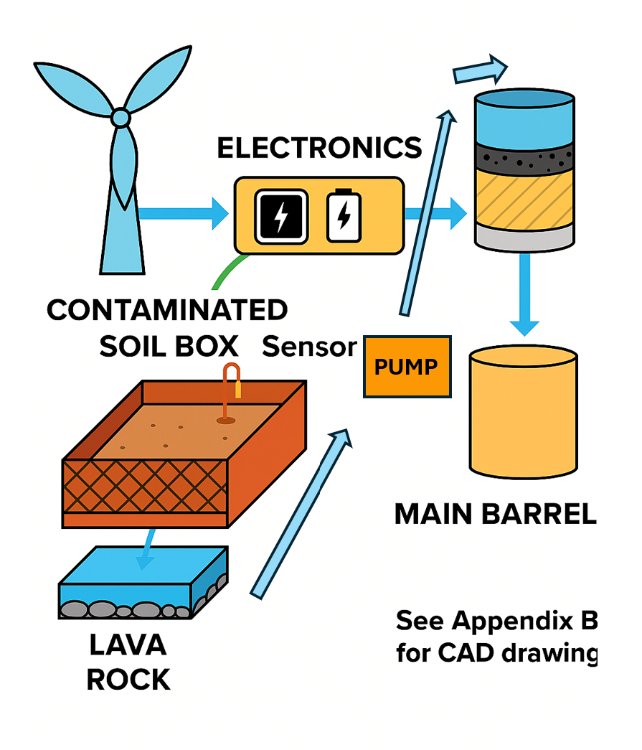

Figure 1  
Flow diagram showing the complete system architecture from wind turbine to water collection, filtration, and sensor data collection. See Appendix B for CAD and additional visuals.

**V. Testing Protocol**

Simulated wildfire contamination was created using:

* Ash-charred soil
* Glyphosate herbicide
* Nitrogen fertilizer
* Garden lime (pH control)

**Procedure:**

* Each day: Add 20L of water → record flow time and volume
* Measure water quality pre- and post-filter
* Track soil moisture and pH daily using sensors
* Visual clarity and physical signs observed

**VI. Results**

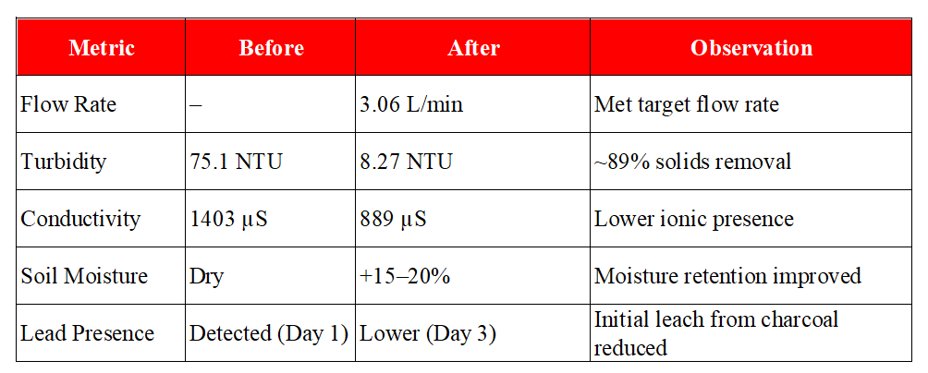

**VII. Financial Assessment**

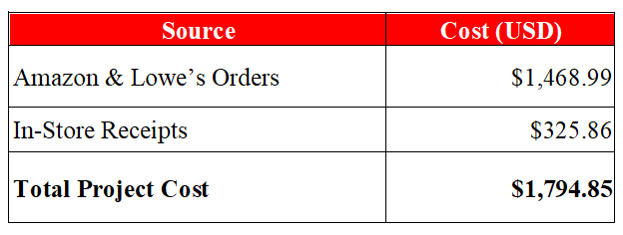

B. Scalability Estimate

* Estimated cost per deployable unit: $4,500–$6,000
* Designed to cover ~1-acre post-fire zone
* Scalable through bulk purchase, grant support, and simplified framing

C. Lifespan of Major Components

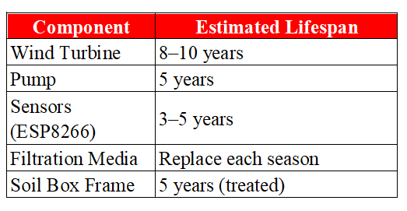

VIII. Stakeholder Relevance

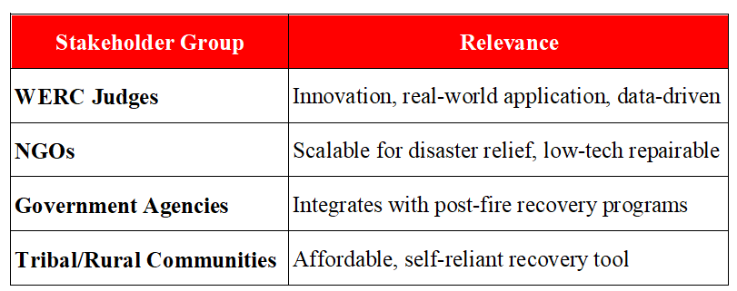

**IX. Future Recommendations**

* Replace coconut charcoal with pre-treated carbon to avoid early leach
* Expand data logging and remote access capabilities
* Explore battery integration with charge controller for hybrid use
* Extend soil trials to 4–8 weeks for long-term data

**X. Conclusion**

This project provides a low-cost, sustainable solution for soil and water restoration in wildfire-affected areas. By using wind energy and natural filtration media, we offer a system that is affordable, effective, and replicable in regions most at risk. With continued testing and scaling, this design could become part of national post-fire recovery efforts.

**Appendix A – Financials**

|  |  |  |  |
| --- | --- | --- | --- |
| **Item** | **Qty** | **Price (USD)** | **Total (USD)** |
| Mini Wind Turbine (50W) | 1 | $269.99 | $269.99 |
| Charge Controller for Mini Turbines | 1 | $19.99 | $19.99 |
| 12V 20Ah Lithium LiFePO4 Battery | 1 | $169.99 | $169.99 |
| Fuse Block (12V) | 1 | $17.59 | $17.59 |
| Voltage Regulator (12V to 5V) | 1 | $14.99 | $14.99 |
| Seaflo 42 Series Diaphragm Pump | 1 | $64.99 | $64.99 |
| Water Tanks (10 liters each) | 2 | $27.99 | $55.98 |
| Coconut Shell Granular Activated Carbon | 1 | $30.00 | $30.00 |
| Capacitive Soil Moisture Sensors | 2 | $8.68 | $17.36 |
| Arduino Nano | 2 | $15.00 | $30.00 |
| ESP8266 Wi-Fi Module | 1 | $8.00 | $8.00 |
| Sper Scientific Turbidity Meter | 1 | $369.00 | $369.00 |
| Apera Instruments AI316 pH Tester | 1 | $168.75 | $168.75 |
| Water Testing Kit | 1 | $32.99 | $32.99 |
| Heavy Metal Testing Strips | 1 | $15.99 | $15.99 |
| Coliform Bacteria Test Kit | 2 | $22.69 | $45.38 |
| 50-Gallon ECO Rain Barrel | 1 | $79.00 | $79.00 |
|  |  | TOTAL | $1,409.99 |

|  |  |  |
| --- | --- | --- |
| **Vendor** | **Item(s)** | **Total (USD)** |
| Walmart | Cotton Balls (x2) | $5.96 |
| Ace Hardware | Killer Weed Remuda GT (Herbicide) | $29.99 |
| Home Depot | Tab Tape, Electrical Tape, Wire, Washers, etc. | $233.39 |
| Guzman's Garden | Charcoal (5 units), Worm Castings | $69.94 |
| Lowes | Tubing, tape, screen, hose clamps | $224.20 |
| Harbor Freight | Mixing drill | $64.99 |
| O'Reilly Auto | Connector | $15.99 |
|  | TOTAL | $644.46 |

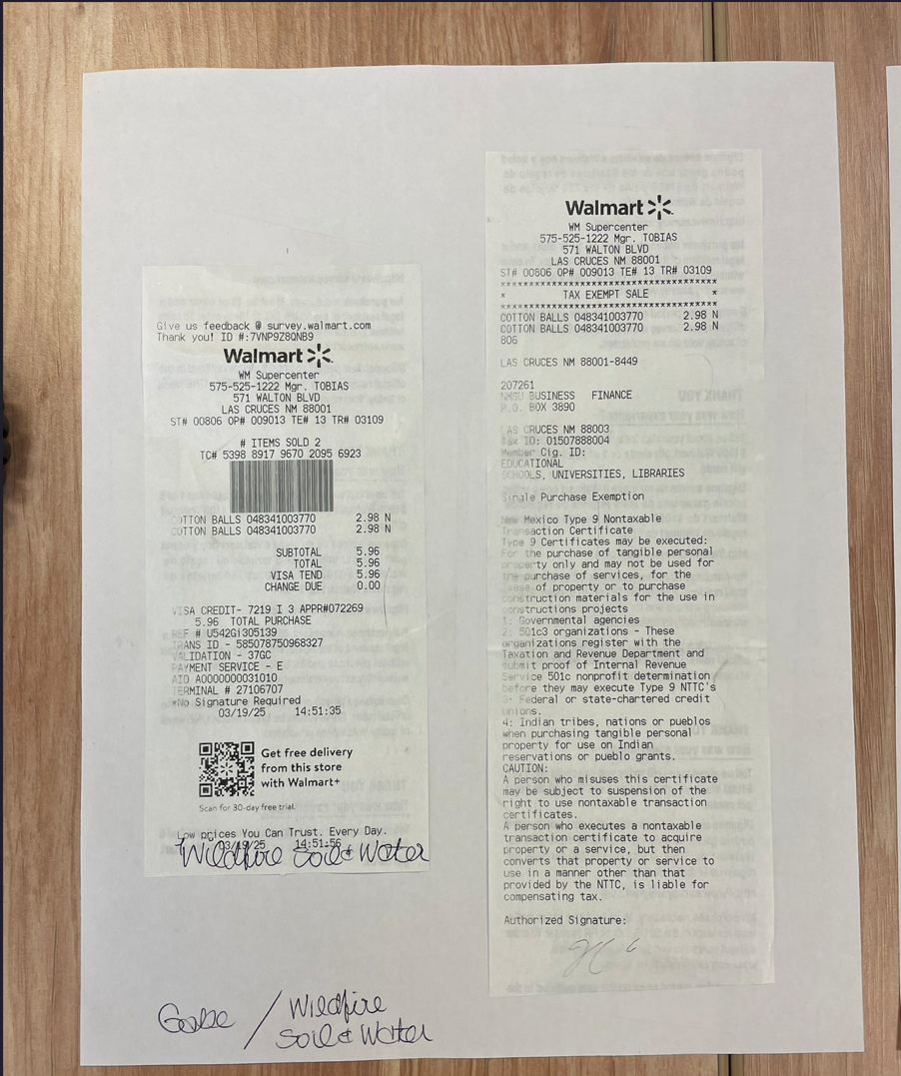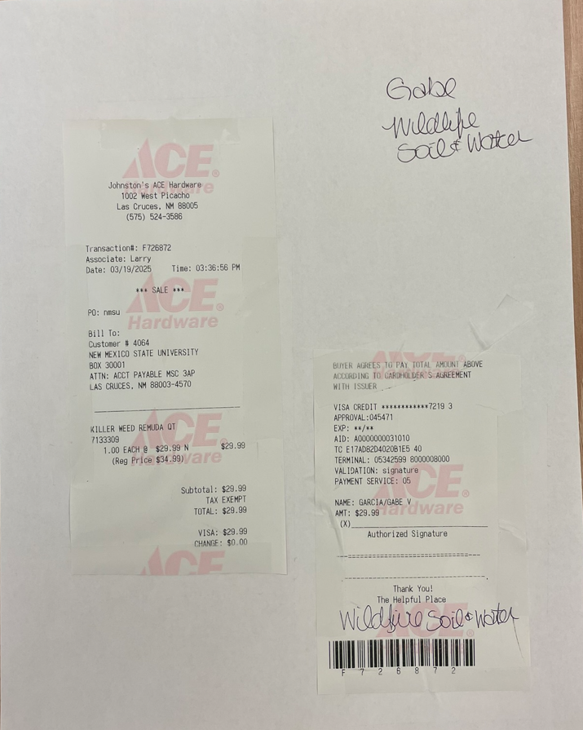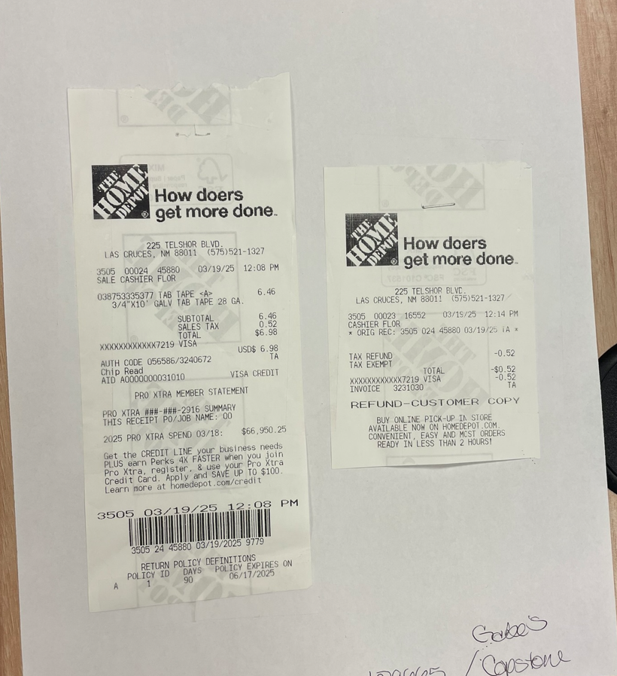

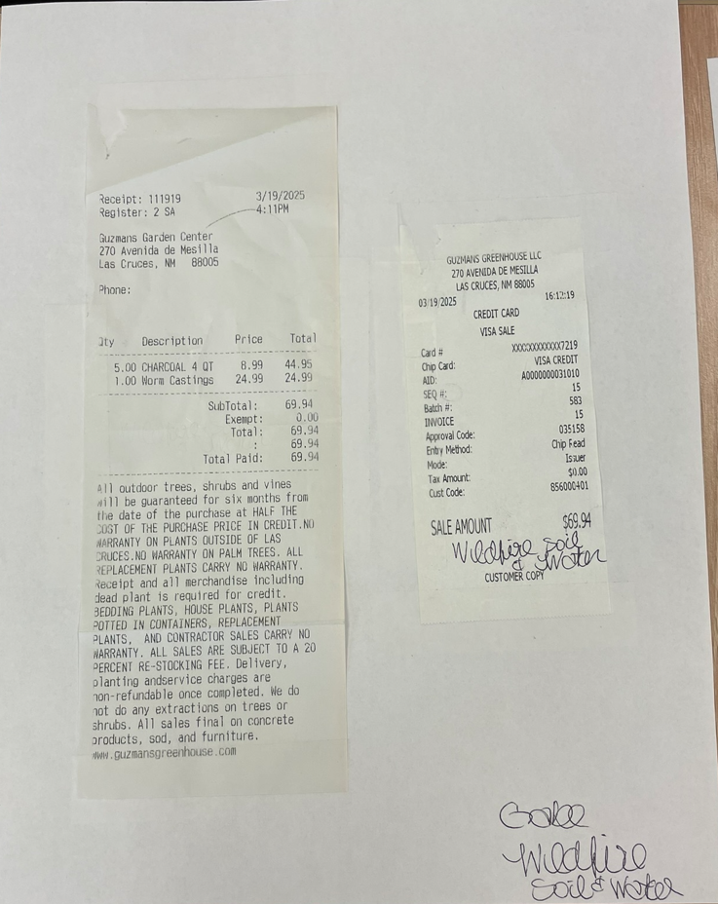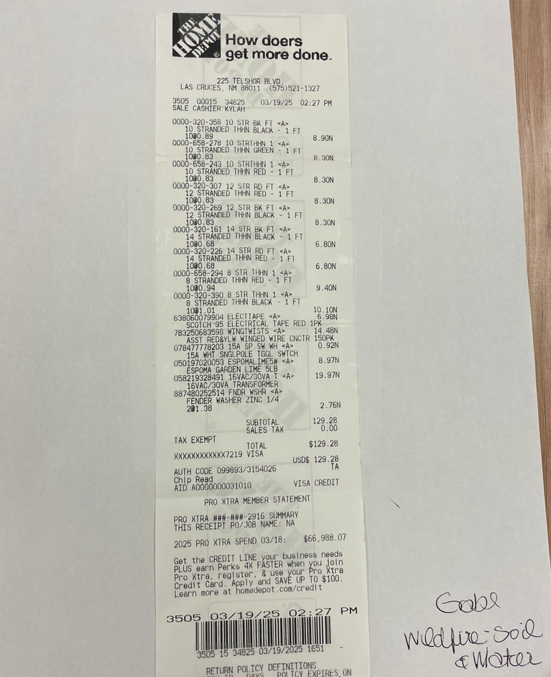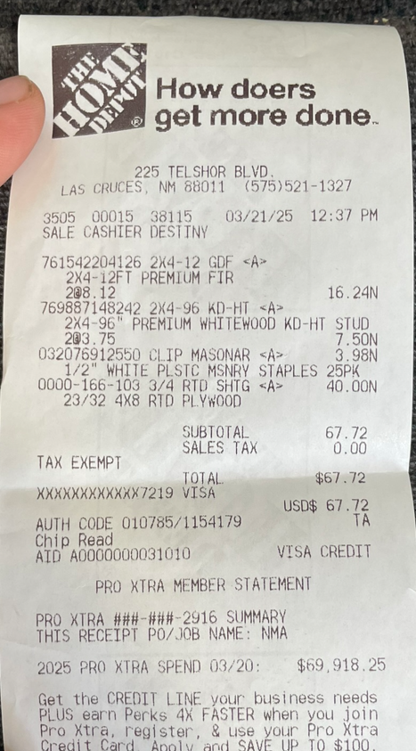

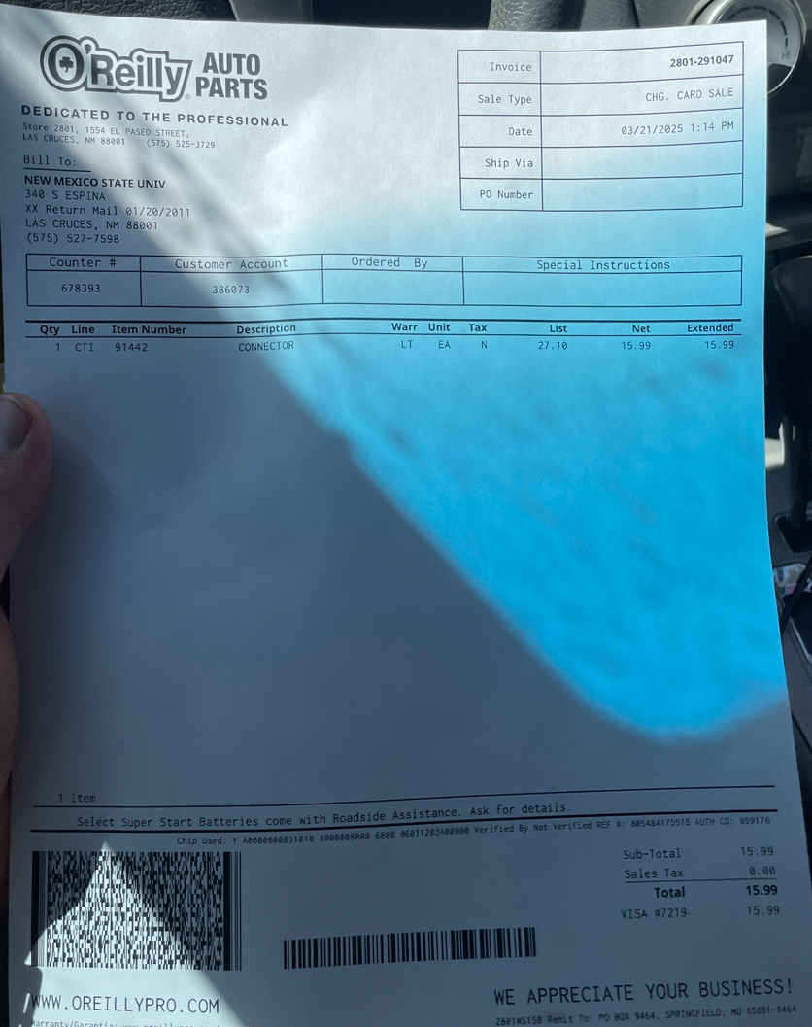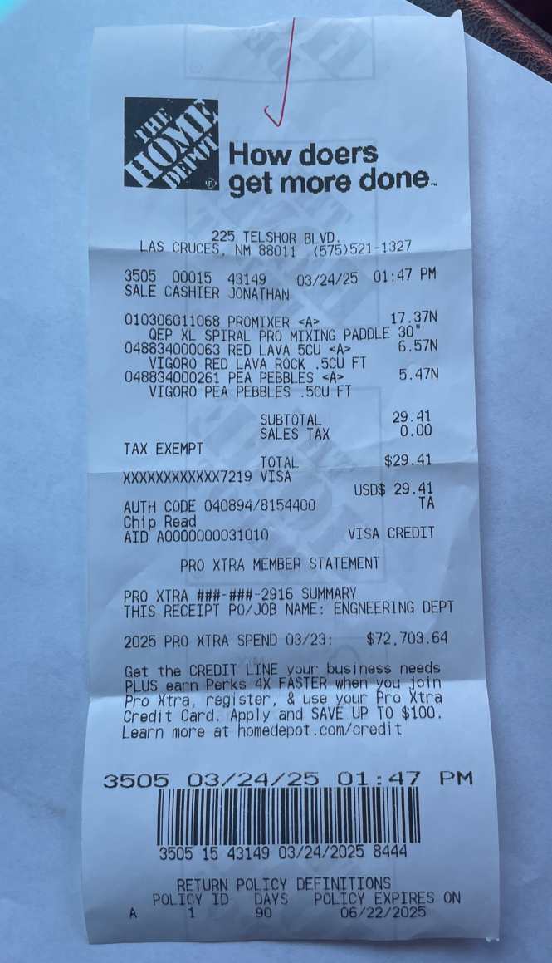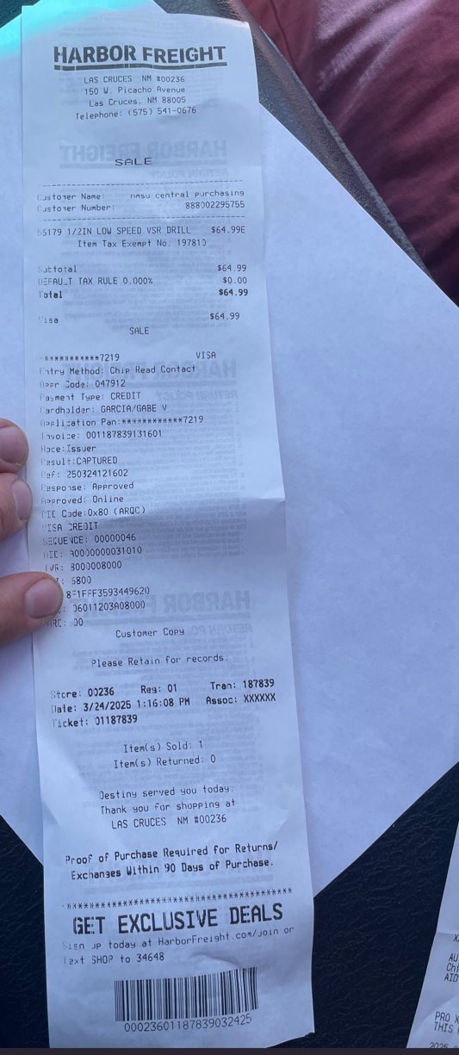

**Appendix B – Technical Drawings & CAD Models**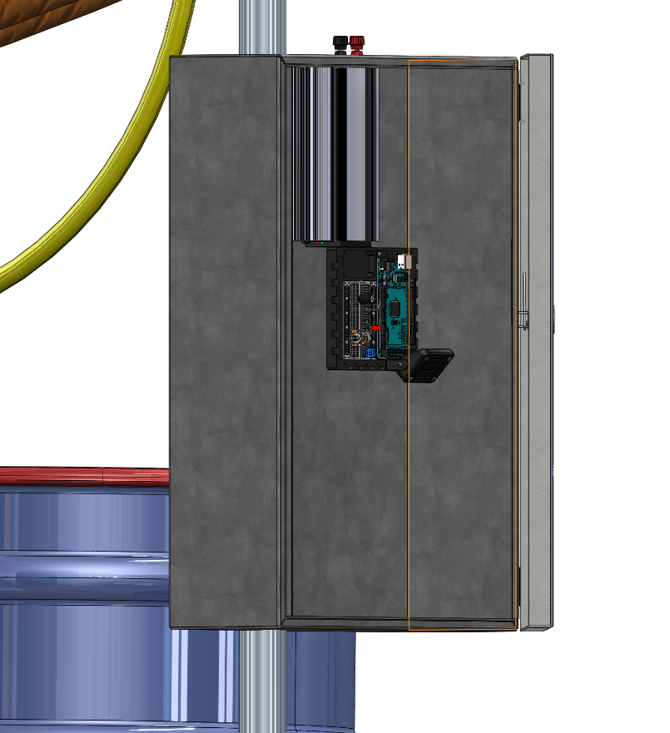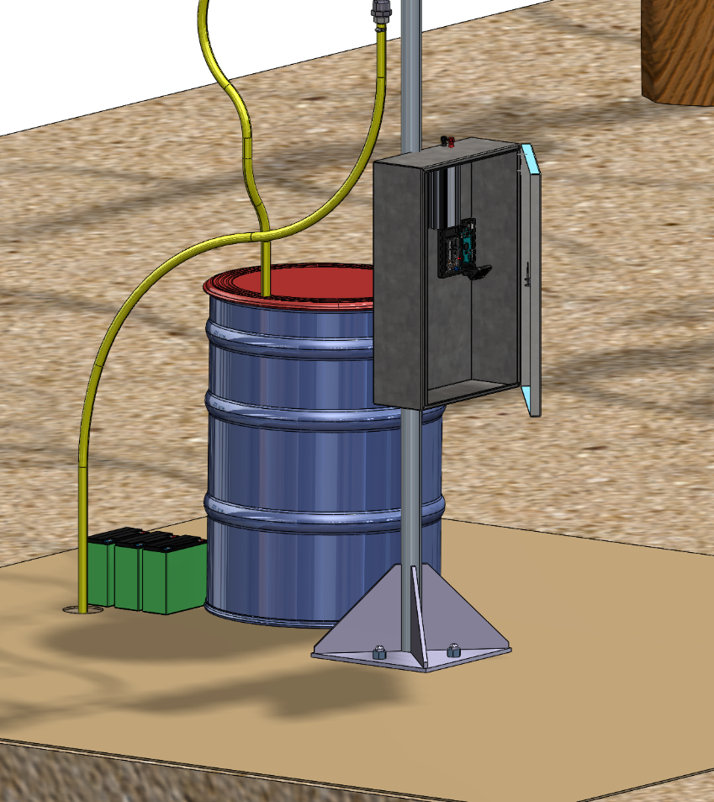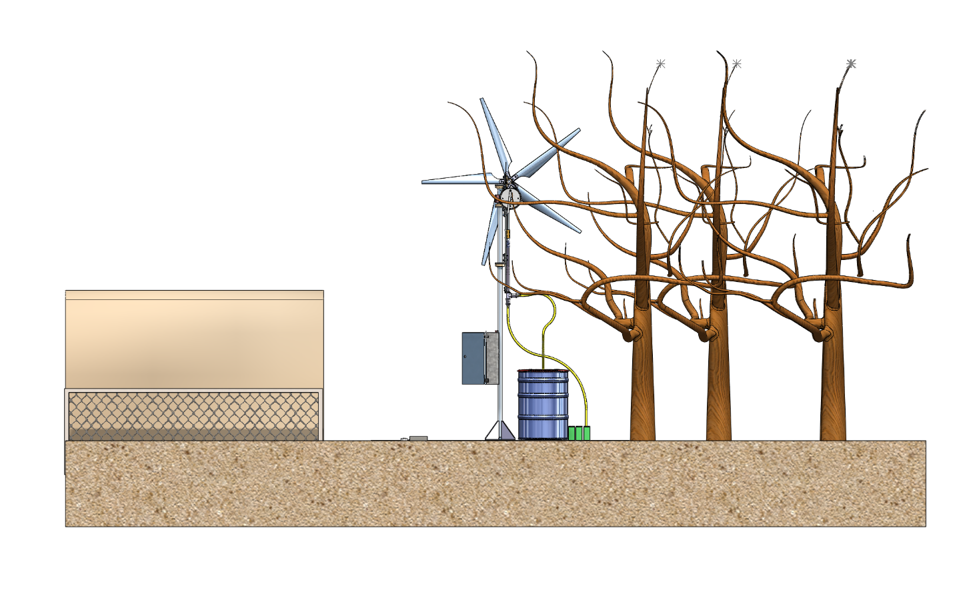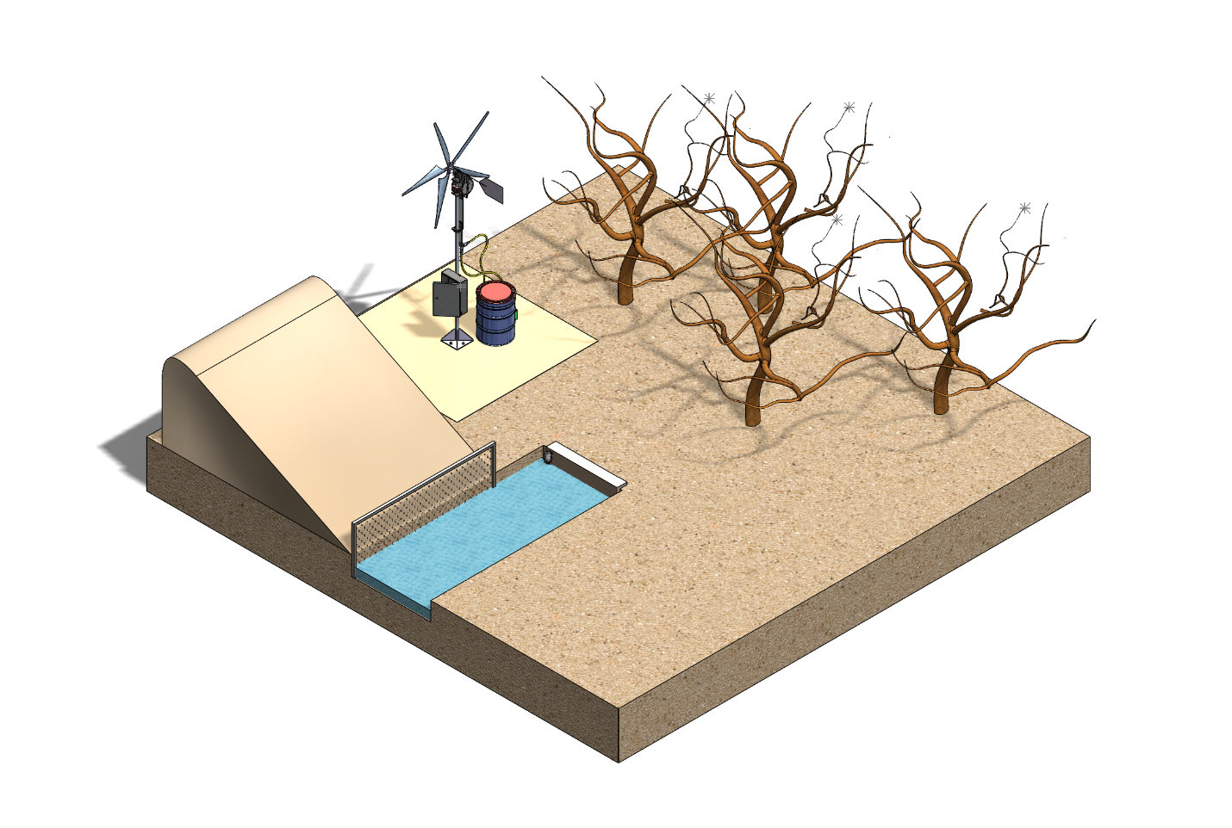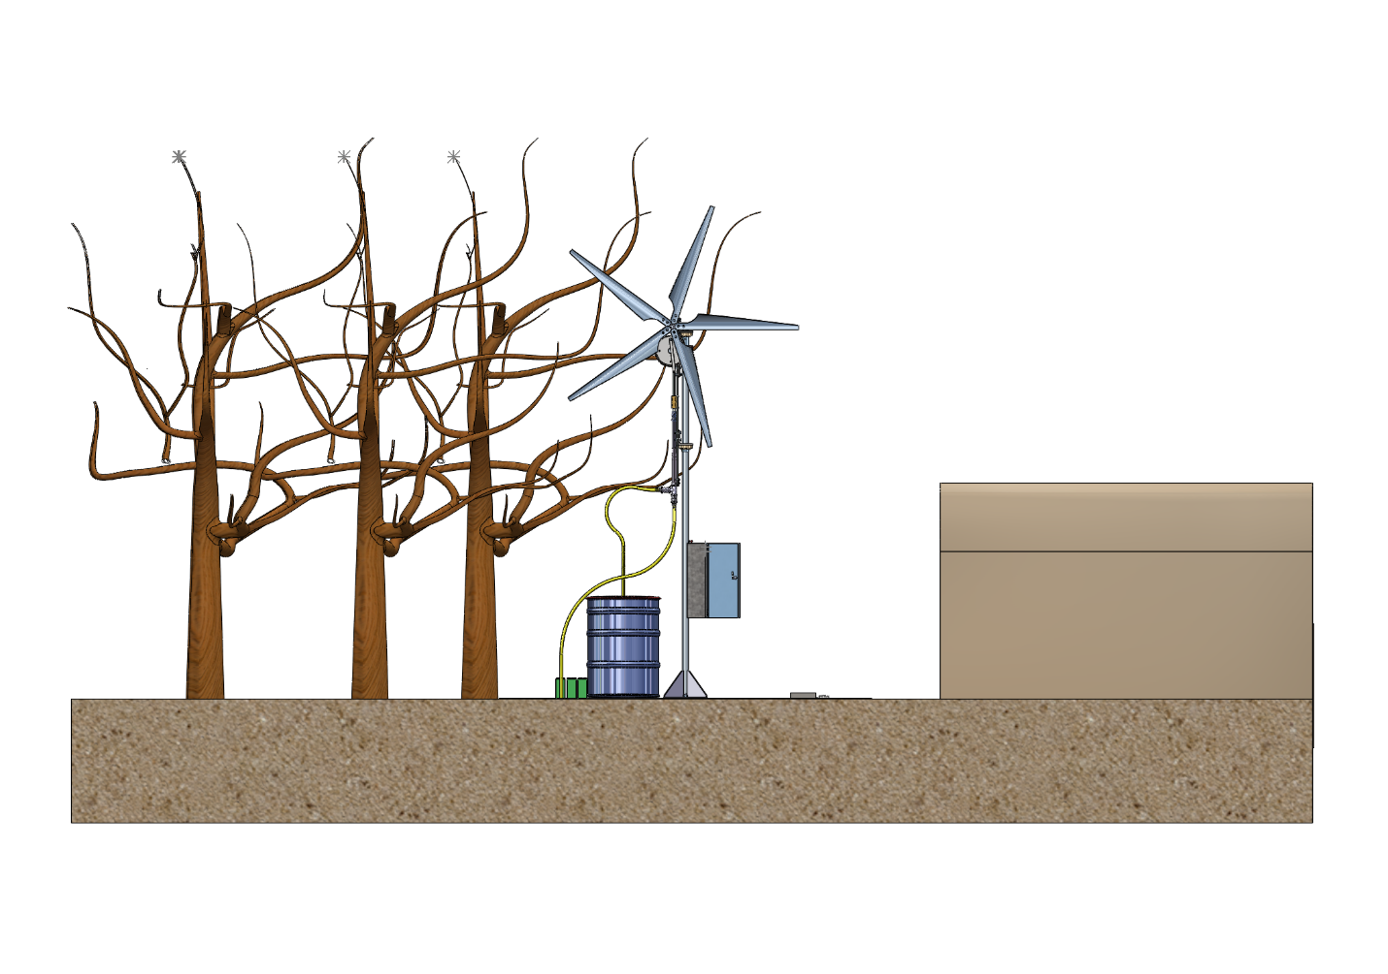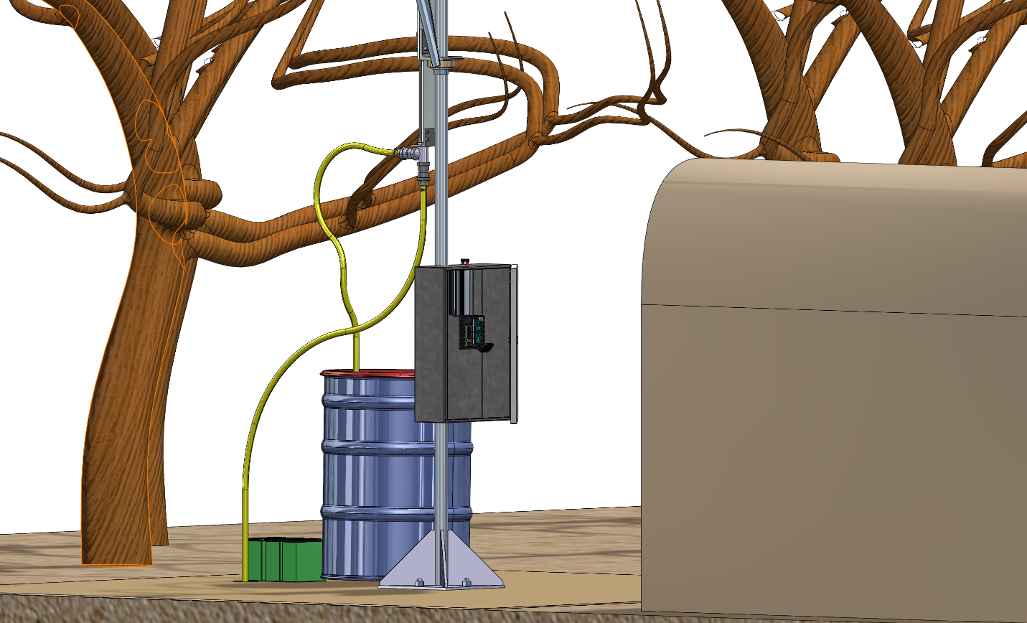

**Appendix C – Testing Data & Logs**

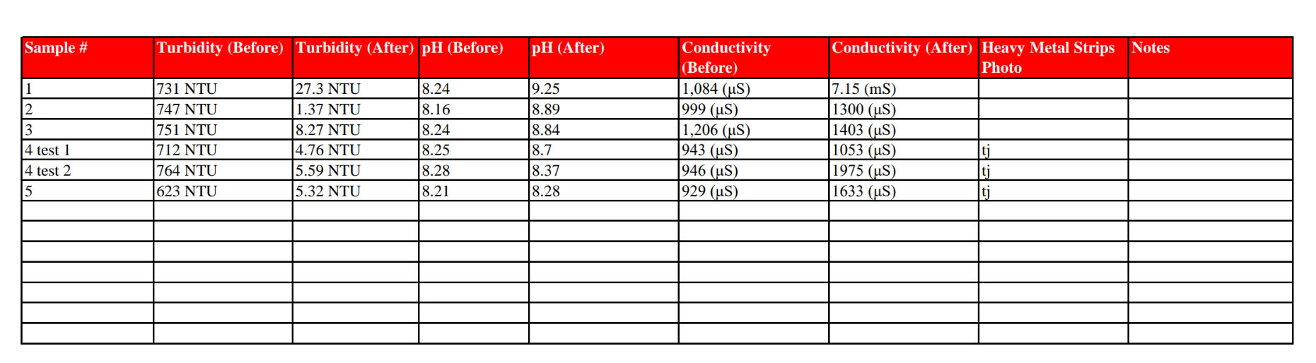

**Table 2** Water quality results across six sample tests before and after filtration through the renewable remediation system. Parameters measured include turbidity (NTU), pH, and electrical conductivity (μS or mS), as well as qualitative observations using heavy metal test strips. Samples 4 and 5 include a second filtration cycle for comparative analysis.

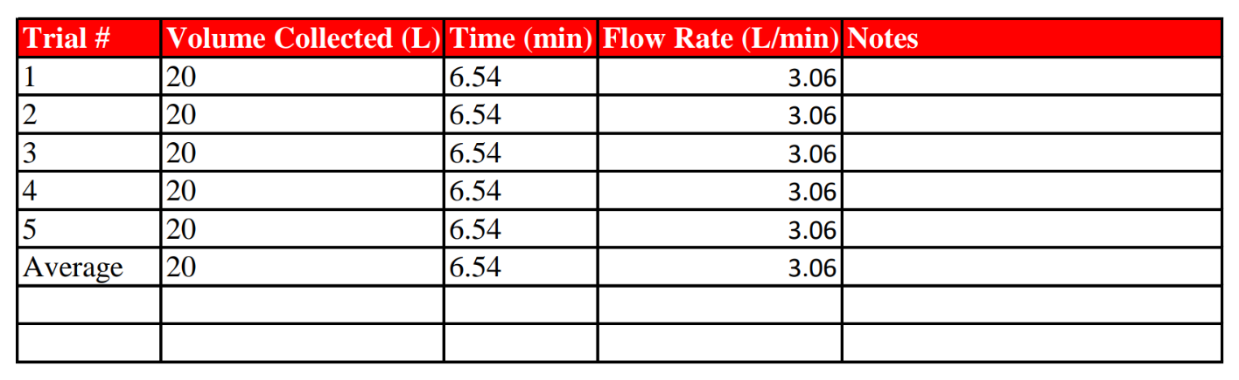

**Table 3 Flow Rate Calculation Summary for Five Trials**  
Each trial involved collecting 20 liters of water over 6.54 minutes. The average flow rate was consistently measured at 3.06 L/min across all trials. These values indicate the system’s reliability and steady performance during multiple filtration cycles.

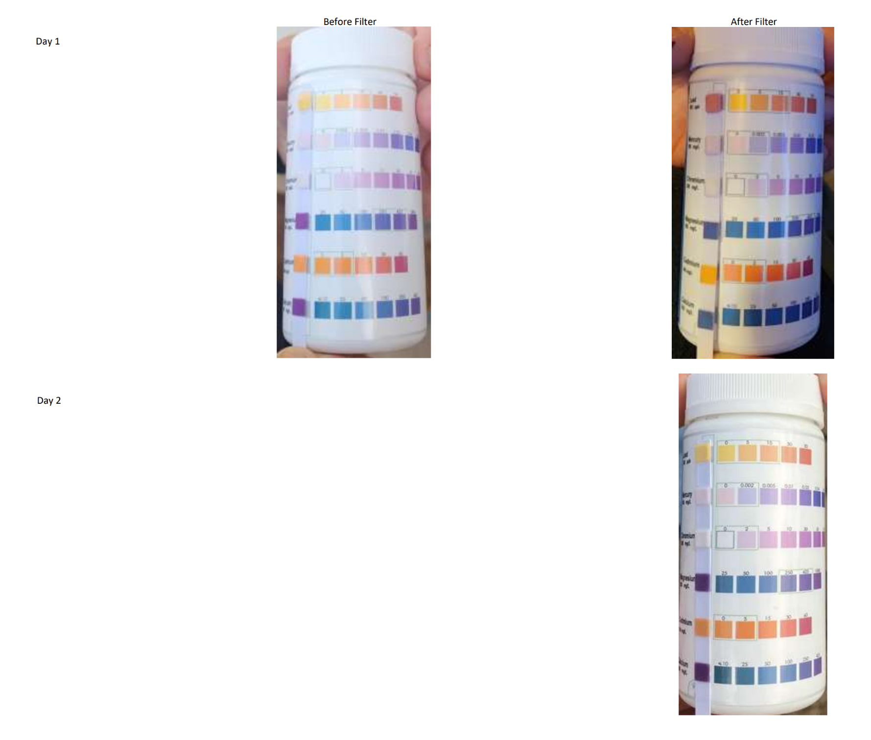

**Figure 2.** Heavy metal test strip results before and after filtration on Day 1 and Day 2. The strips indicate visual changes in lead (Pb) and other metal concentrations. A noticeable increase in lead presence was observed on Day 1 after filtration, likely due to leaching from the coconut-based activated charcoal. No detectable heavy metals were observed after system stabilization on Day 2.

**Appendix D – Arduino & Python Code**

**Arduino Code**

#include <Wire.h>

#include <rgb_lcd.h>

// Initialize Grove RGB LCD

rgb_lcd lcd;

// Moisture sensor settings

const int sensorPin = A0;

const int dryValue = 300;

const int wetValue = 650;

const int thresholdLow = 30;

const int thresholdMed = 60;

void setup() {

  Serial.begin(9600);

  lcd.begin(16, 2); // 16 columns, 2 rows

}

void loop() {

  // Read sensor value

  int sensorValue = analogRead(sensorPin);

  int moisture = map(sensorValue, dryValue, wetValue, 0, 100);

  moisture = constrain(moisture, 0, 100);

  // Print to Serial Monitor

  Serial.print("Soil Moisture: ");

  Serial.print(moisture);

  Serial.println("%");

  // Show percentage and status

  lcd.clear();

  lcd.setCursor(0, 0);

  lcd.print("Moisture: ");

  lcd.print(moisture);

  lcd.print("%");

  lcd.setCursor(0, 1);

  if (moisture < thresholdLow) {

    lcd.setRGB(255, 0, 0);  // Red

    lcd.print("💧 WATER NOW!");

  } else if (moisture < thresholdMed) {

    lcd.setRGB(255, 255, 0); // Yellow

    lcd.print("⚠️ Soil Dry");

  } else {

    lcd.setRGB(0, 255, 0);  // Green

    lcd.print("🌱 Soil OK");

  }

  delay(2000);

  // Display progress bar

  int blocks = map(moisture, 0, 100, 0, 16); // Max 16 columns

  lcd.clear();

  lcd.setCursor(0, 0);

  lcd.print("Moisture Level:");

  lcd.setCursor(0, 1);

  for (int i = 0; i < 16; i++) {

    if (i < blocks) {

      lcd.print((char)255); // Solid block

    } else {

      lcd.print(" ");

    }

  }

  delay(2000); // Wait before next reading

}

**PHYTHON CODING FOR TEMPERATURE READINGS AND HUMIDITY SENSOR READING AND AUTOMATED .CVS FILING**

import serial import csv import time import requests from datetime import datetime

*=== CONFIG ===*

arduino_port = 'COM3' # 🛠️ Replace with your actual Arduino port if needed baud_rate = 9600 filename = "moisture_temp_log.csv" API_KEY = '16b2757c444b4da4e8f561afa075f604' CITY = 'Las Cruces,US' temperature_fetch_hours = [8, 14, 20] # Fetch temperature at 8 AM, 2 PM, 8 PM

*=== Weather API Function ===*

def fetch_temperature(): try: url = f'[https://api.openweathermap.org/data/2.5/weather?q={CITY}&appid={API_KEY}&units=metric'](https://api.openweathermap.org/data/2.5/weather?q=%7BCITY%7D&appid=%7BAPI_KEY%7D&units=metric%27) response = requests.get(url) if response.status_code == 200: data = response.json() temperature = round(data['main']['temp'], 1) print(f"🌡️ Las Cruces Temp Fetched: {temperature}°C") return temperature else: print(f"🌐 API error: {response.status_code}") return "N/A" except Exception as e: print("🌐 Weather fetch error:", e) return "N/A"

*=== Connect to Arduino ===*

ser = serial.Serial(arduino_port, baud_rate) time.sleep(2) # Wait for Arduino to reset

*=== Initialize temp value ===*

current_temperature = fetch_temperature() last_checked_hour = datetime.now().hour

*=== Start Logging ===*

with open(filename, mode="w", newline="") as file: writer = csv.writer(file) writer.writerow(["Timestamp", "Soil Moisture (%)", "Las Cruces Temp (°C)"])

print("🌱 Logging started... Press Ctrl+C to stop.\n")   
   
try:   
    while True:   
        line = ser.readline().decode("utf-8").strip()   
        now = datetime.now()   
        current_hour = now.hour   
   
        # Check if it's time to fetch temperature again   
        if current_hour in temperature_fetch_hours and current_hour != last_checked_hour:   
            current_temperature = fetch_temperature()   
            last_checked_hour = current_hour   
   
        if "Moisture" in line:   
            try:   
                moisture = line.split(":")[1].strip().replace("%", "")   
                timestamp = now.strftime("%Y-%m-%d %H:%M:%S")   
                writer.writerow([timestamp, moisture, current_temperature])   
                print(f"💾 {timestamp} | Moisture: {moisture}% | Temp: {current_temperature}°C")   
            except Exception as e:   
                print("⚠️ Error saving row:", e)   
   
except KeyboardInterrupt:   
    print("\n🛑 Logging stopped.")   
    ser.close() 

**Appendix E – Photos**

**Figure 1(Below): Prototype Assembly in its Entirety**

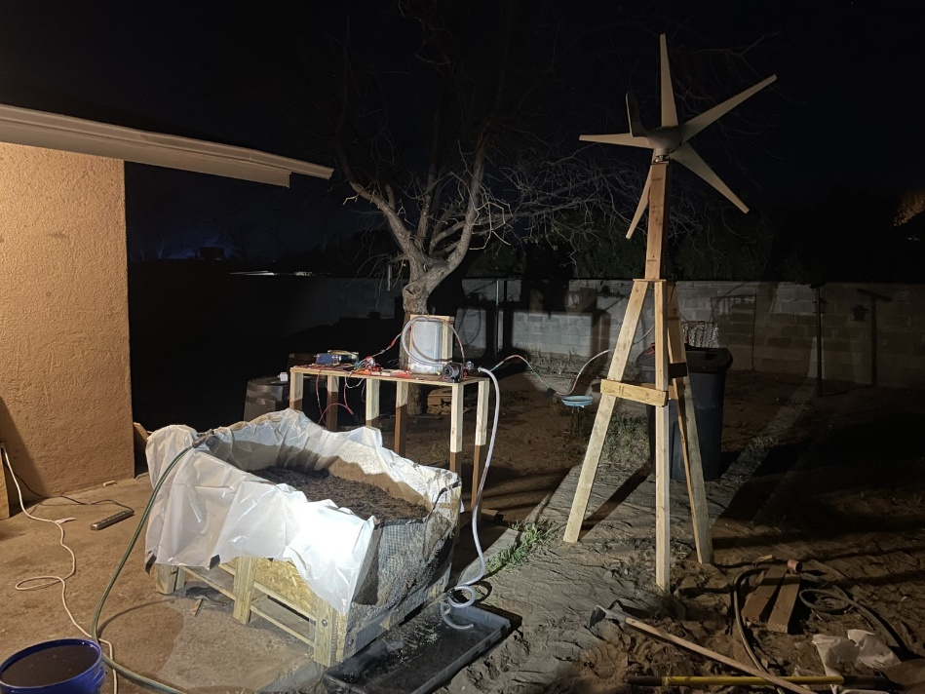

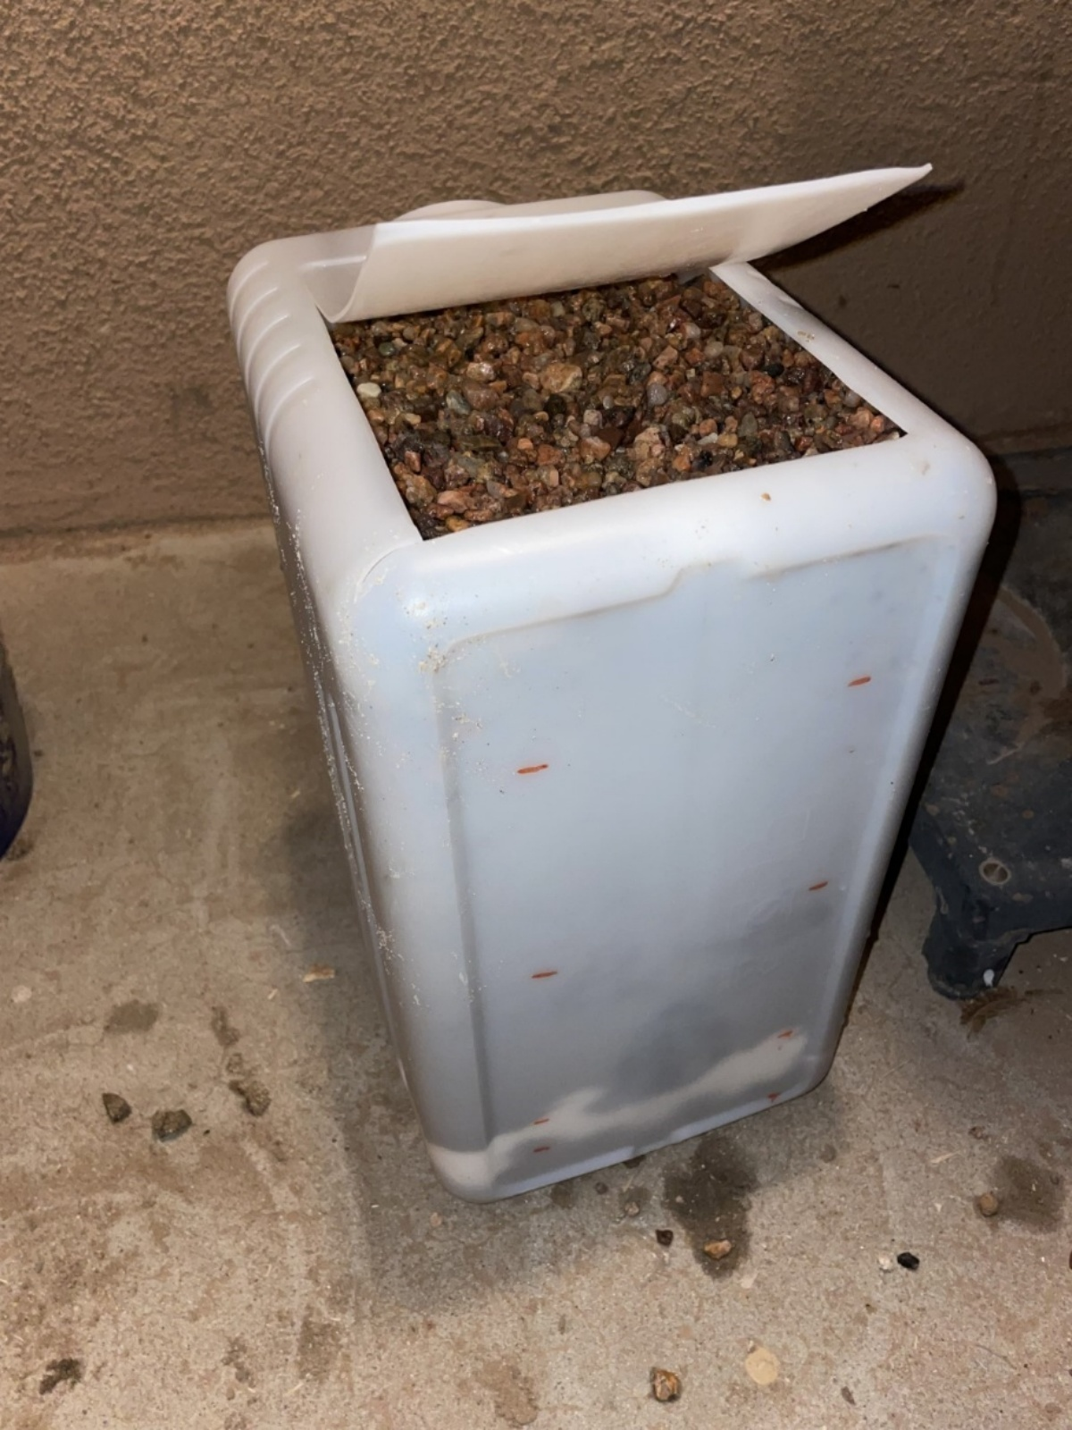

**Figure 2 (Above): Filter housing with open top for filter maintenance. The top layer of the filter is visible.**

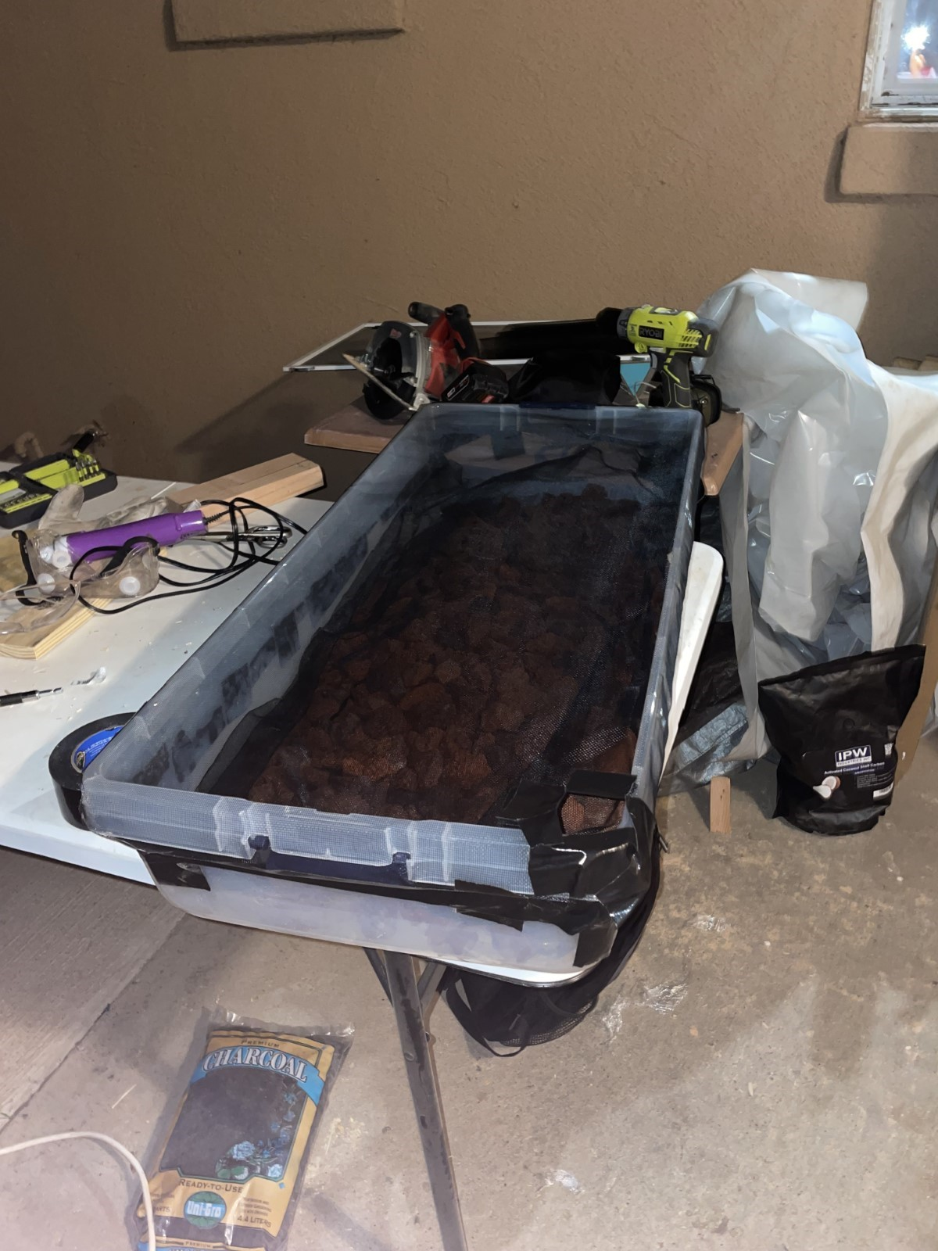

**Figure 3 (Above): Close-up of the pre-filter water collection tu**

**Appendix F – MSDS Sheets**

## MSDS Reference Table

|  |  |  |
| --- | --- | --- |
| Material | Description | MSDS Link |
| Activated Charcoal (Carbon) | Used in water filtration | https://www.parchem.com/siteimages/attachment/activated%20carbon%20msds.pdf |
| Coconut Activated Carbon | Natural charcoal filtration media | https://sds.aquaphoenixsci.com/SDS/180103_Charcoal%20Activated%20Carbon%20%28S25246%29%20_CanadaSDS_English_2018_8_20.pdf |
| Sand and Gravel | Filtration and drainage layers | https://www.lgeverist.com/safeDatasheets/Sand%20%26%20Gravel%20SDS.pdf |
| Lava Rock | Drainage and mechanical filtration | https://www.martinmarietta.com/products/safety-data-sheets |
| Garden Lime (Calcium Carbonate) | pH stabilizer in soil | https://fscimage.fishersci.com/msds/89308.htm |
| Clay Soil | Soil simulation layer | https://www.missouribotanicalgarden.org/portals/0/Soil_MSDS_Example.pdf |
| Organic Compost | Nutrient recovery media | https://www.recology.com/wp-content/uploads/2016/01/Compost-Material-Safety-Data-Sheet.pdf |
| Nitrogen Fertilizer | Soil nutrient for testing plant growth | https://www.sigmaaldrich.com/US/en/sds/sial/221244 |
| Herbicide (Glyphosate-based) | Simulated contaminant | https://sds.agrian.com/labelcenter/sds_10743_466.pdf |
| Cotton | Organic filtration layer | Use general caution; no specific SDS required for untreated cotton |

All MSDS were retrieved from official manufacturer and chemical safety sources. Materials were selected based on safety, environmental compatibility, and project effectiveness.

**Appendix G – Third-Party Audits (To Be Collected)**